Project 3: Build Data Dashboards  
Flight Delays and Cancellations

This data comes from a Kaggle dataset, it tracks the on-time performance of US domestic flights operated by large air carriers in 2015. My Target is to know some information about:

* Which states, days have more cancellations flights
* What is the reasons of cancellation ?
* Which Airlines are more likely to have delays

**Kaggle link:**[**https://www.kaggle.com/usdot/flight-delays/data**](https://www.kaggle.com/usdot/flight-delays/data)

**First of all, I filtered data source and I have joined the table Flights.csv (main) with the other ones Airports and Airlines .**

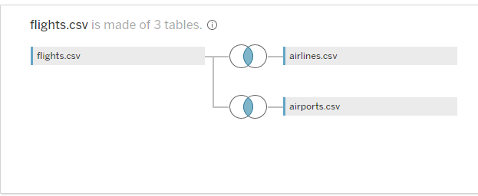

**Visualization 1:**

* Count of cancelled flights for all states per day ?

***Tableau link :***

[Edit | - Count of cancelled flights for all states per day ? (tableau.com)](https://public.tableau.com/authoring/-Countofcancelledflightsforallstatesperday/Dashboard1#1)

**Summary and design :**

**I divided this dashboard into two visualization. Map visualization show us sum of cancelled flights per state and bar chart show us the most cancelled flights for all states based on days**

**When hover over the map we show country, state and number of cancelled flights.**

**________________________________________________________**

**Visualization 2:**

* What are the reasons of cancellation ?

***Tableau link :***

[Edit | - What are the reasons of cancellation ? (tableau.com)](https://public.tableau.com/authoring/-Whatarethereasonsofcancellation/Dashboard2#1)

**Summary and design :**

**I divided this dashboard into two visualization. Packed bubbles visualization show us what is the most reasons for cancelling flights and all filter for every month and day , the second visualization is a bar chart show the number of cancelled flights for each month and the volume for each reason.**

**We find that the weather condition is the most case for cancelling flights at much times.**

**Visualization 3:**

* What is the delay time for airports and airlines ?

***Tableau link :***

[Edit | - What is the delay time for airports and airlines ? (tableau.com)](https://public.tableau.com/authoring/-Whatisthedelaytimeforairportsandairlines/Dashboard3#1)

**Summary and design :**

**I divided this dashboard into two bar charts visualization.the first one show us what is the arrival delay at the airports and we find that Chicago O'Hare airport has the most arrival delay , the second visualization is a bar chart show delay of airlines .. Southwest Airline Company has the most airline delay**

**________________________________________________________**